MENU
  - Teacher Appreciation Week
Sponsored by:
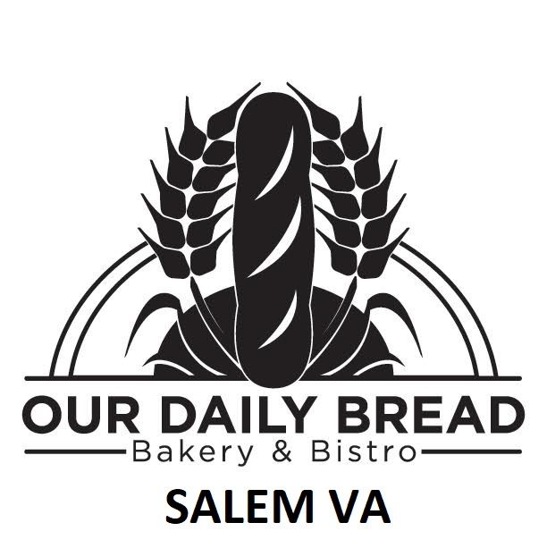

Egg Salad Sandwich

Housemade egg salad served on your choice of bread or croissant

Chicken Salad Sandwich

Housemade chicken salad served on your choice of bread or croissant

Ham and Swiss Baguette

Ham and Swiss cheese served on a French baguette with whole grain mustard

Roast Beef Baguette

Roast beef and cheddar cheese served on a French Baguette with lettuce, tomato and horseradish cream sauce

Oven Roasted Balsamic Chicken Salad

Roasted Balsamic marinated chicken breast served on a bed of mixed greens with tomatoes, cucumbers, and red onions, with your choice of dressing

Please provide you teacher ID to receive your meal FREE courtesy to Northpoint Ins Adv

