MENU
  - Teacher Appreciation Week
Sponsored by:
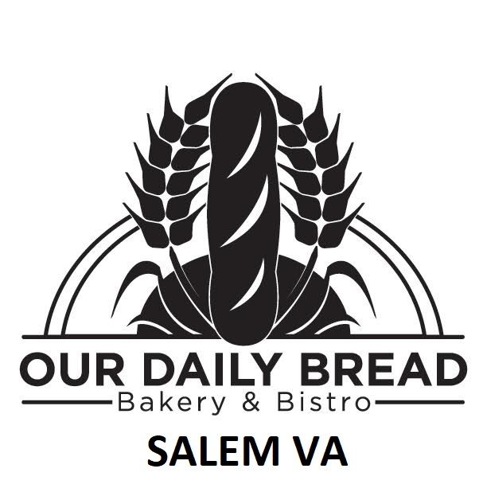

French Toast

Brioche French toast with whipped cream

Country Omelet

Fluffy 3 egg omelet filled with ham, bacon, and swiss cheese, served with your choice of toast

Mushroom Omelet

Fluffy 3 egg omelet filled with mushrooms, bacon, and swiss cheese, served with your choice of toast

Greek Omelet

Fluffy 3 egg omelet filled with spinach, roast tomatoes, and feta cheese, served with your choice of toast

Garden Omelet

Fluffy 3 egg omelet filled with Chef’s choice of vegetables, served with your choice of toast

Please have your teacher ID ready to receive your meal FREE thanks to Northpoint Insurance of Salem.

